Q2. Copy history Command in specific file and send to every hour to s3 bucket

Step 1:- Launch instance and apply role s3 bucket access

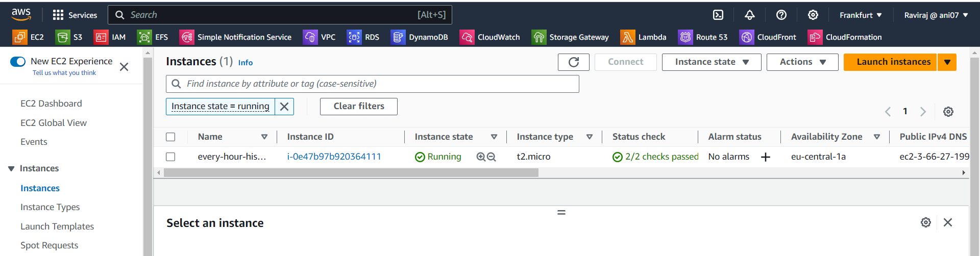

Step 2:- Get access of this instance in your system

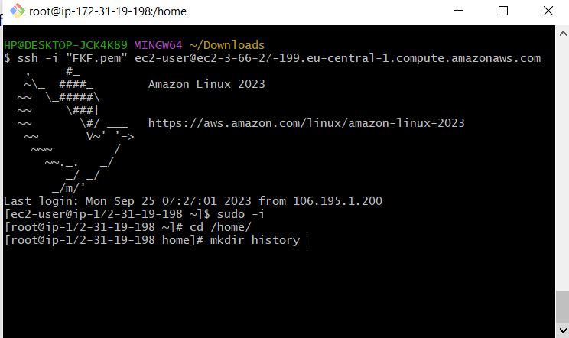

Step 3:- Then create script with extension .sh and these script have permission to execute.

In that script you must have enter your user credential

Access key

Secrete key

Bucket name

Region name

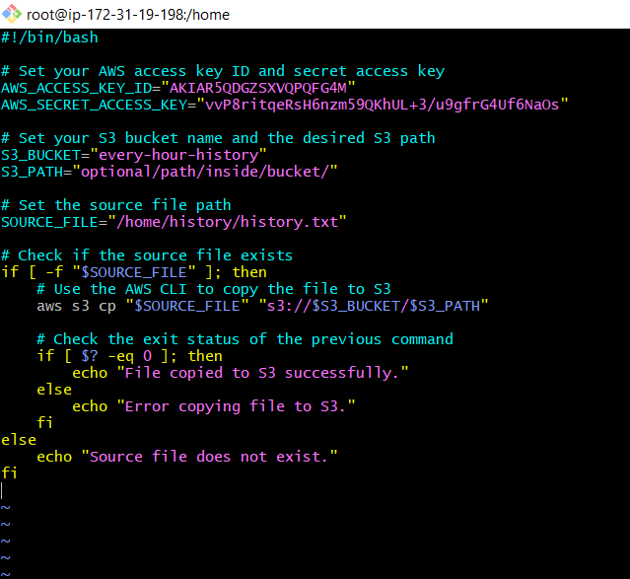

Then save this file with historytos3.sh extension

Chmod 555 historytos3.sh

Step :- Now install cronie and start assign crontab job for our script

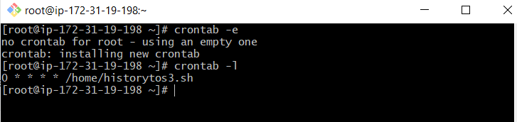

Every hour history will be update in bucket and on bucket versioning to save the date on s3

